New Initiative Aims to Protect Birds on Private Lands
Land Trust Alliance and Cornell Lab of Ornithology join forces

www.birdtrust.org

The Cornell Lab of Ornithology and the Land Trust Alliance have formed a new partnership to help protect birds on private lands. The goal of the new Land Trust Bird Conservation Initiative and associated website (birdtrust.org) is to improve conservation for declining species by pairing the bird conservation community with land trusts, which collectively protect more than 24 million acres of private land nationwide.
"It’s a natural fit," said Ron Rohrbaugh, the Cornell Lab's Assistant Director of Conservation Science. "Thousands of local and regional land trusts are already protecting private land for all sorts of reasons. This initiative enhances that work by adding specific strategies for bird conservation and by providing land trusts with new tools and science support to help them make even better decisions about which lands are worth their resources."

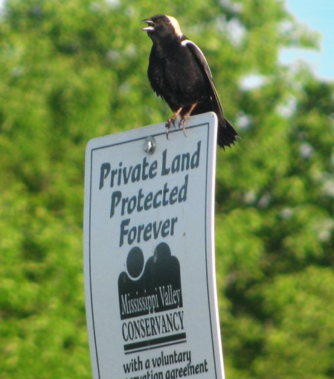
"Land trusts across the United States make critical contributions to conserving birds and, in return, birds benefit land trusts by helping them grow support and increase their capacity to conserve land," said Erin Heskett, the Alliance’s director of national and regional services. "Our ongoing, cooperative work with the Cornell Lab highlights the role land trusts can play in sustainably increasing the pace and effectiveness of bird conservation."
Abbie Church
A recent survey conducted by the Cornell Lab found that birds and bird habitat are a priority for two-thirds of land trusts. Many land trusts are already contributing to bird conservation in a variety of ways, such as putting land under easement and managing their lands to enhance habitat for birds. At the same time, a high percentage of land trusts expressed a desire for new resources, tools, and technical support to amplify and sharpen the focus of their bird conservation efforts.
With that in mind, the Alliance and Cornell Lab partnered to create the Land Trust Bird Conservation Initiative and website. The Resources Directory of birdtrust.org is full of technical information and funding resources that were gleaned from conservation partners across the United States, and are intended to aid land trusts in strategic bird conservation.
"How do you know which species are present on the land you want to conserve? How can you find funding or volunteers to support bird conservation efforts?" said Ashley Dayer, who conducted the survey for the Cornell Lab. "This website is designed to make such information easy for land trusts to access and it provides tips for raising funds, monitoring birds, and finding partnership opportunities. It’s a one-stop shopping site for land trusts interested in enhancing their land conservation efforts through birds."

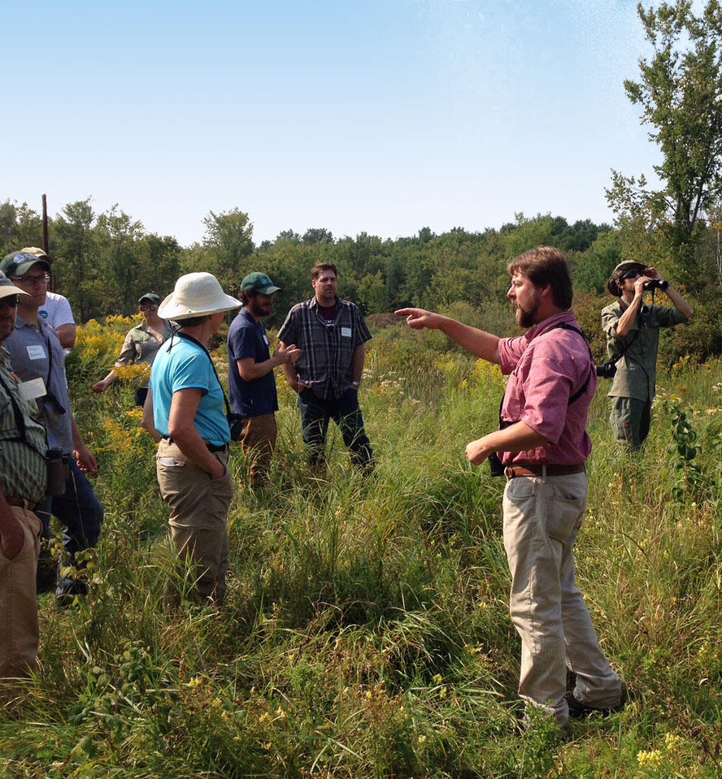
The Cornell Lab is also working to connect land trusts that share oversight of one or more bird species of concern in a region. The Lab holds workshops and provides technical support to help these collaborative groups strengthen bird conservation in their region.
Ashley Dayer

Many land trusts have already found success in conserving both land and birds. Their stories are featured on the new website and serve to inspire others.

"We can’t move the needle on declining bird populations until we are able to address their conservation needs on private lands," explained Rohrbaugh. "This innovative partnership represents an unprecedented opportunity for the bird conservation community and land trusts to help buoy bird populations on millions of privately-owned acres."
Funding for the Land Trust Bird Conservation Initiative and birdtrust.org was provided by the Sarah K. de Coizart Foundation, the Land Trust Alliance's New York State Conservation Partnership Program, and Wings Over Western Waters via resources from the Intermountain West Joint Venture and Pacific Birds Habitat Joint Venture.

